Robyn’s Rocket social story
Robyn’s Rocket will happen on Thursday 14th September 2023 7:45-11:00pm, It is a relaxed performance so you do not have to stay in the space the whole time, and can do what you need to feel comfortable e.g stim , tic etc
Please note : Café OTO have recently changed when they open for gigs, We are hoping we will be ready to open at 7:30pm but we cannot guarantee this , but we will defiantly be open at 8pm, we hope this will not cause any extra stress.

ID = Image description
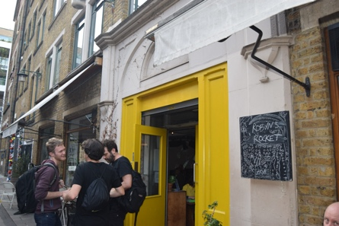  ID a building with a yellow door (the door has been painted since this photo and is green) a group of people stand outside with a chalkboard that says Robyn’s Rocket | You might have to wait outside until café OTO is ready
ID: a line of people entering through the yellow doors and talking to a person sat at a table . | When the doors are opened you can come inside café OTO.  You will be asked  if you have bought a ticket or would like to buy one
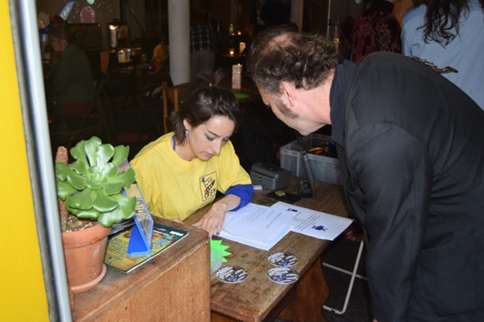  ID : a man in a dark jacket speaks to someone in a Robyn’s Rocket crew T shirt sat at a desk. | If you have bought a ticket the person sitting by the door will ask for your name so they can find your name on the list of people who have bought tickets. NOTE We do not give out physical tickets
ID : a man in a dark jacket speaks to someone in a Robyn’s Rocket crew T shirt sat at a desk. | If you have not bought a ticket , you will be asked if you would like to pay by Cash or card. You can pay the person at the table . NOTE We do not give out physical tickets
ID: outline of a stamp | You will be offered a stamp on your hand, it is ok to say no.
ID: a badge made from silver card in the shape of a rocket with 3 purple windows | You will be given a rocket badge  The rocket badge is used to tell other people how much communication you want with other people
ID: a badge made from silver card in the shape of a rocket with 3 purple windows Rocket pointing up | Place your rocket with the tip pointing toward the sky if your happy to talk to anyone
Photo description a badge made from silver card in the shape of a rocket with 3 purple windows Rocket pointing sideways | Place your rocket sideways if you inly want to talk to people you know already ,
Photo description a badge made from silver card in the shape of a rocket with 3 purple windows Rocket pointing down | place your rocket with the tip pointing toward the floor if you do not want to talk to anyone  You can change your rocket position as much as you want.
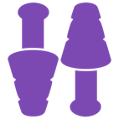  ID: Symbols for ear defenders, sunglasses and ear plugs. | If you want to you can borrow a pair on sunglasses or ear defenders , or have a pair of ear plugs , you can get these at anytime.
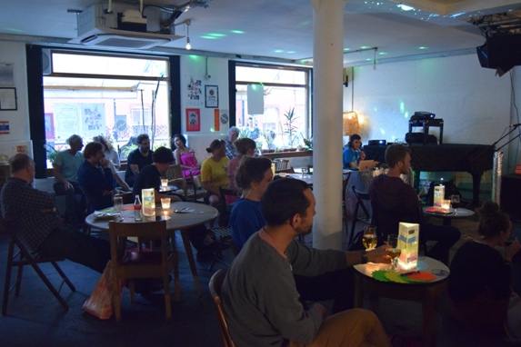  ID: Café OTO inside a room with large windows and small tables with lights | Choose somewhere to sit or stand  You can sit or stand anywhere that is not blocking the fire exit , entrance, toilets doors.
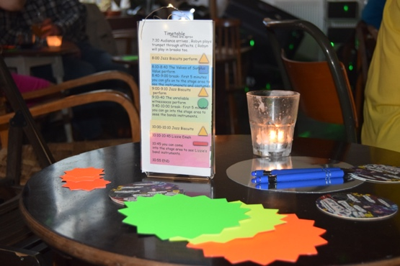  ID: a table with a plastic timetable holder , candle , card stars ,and pen and a symbol of a whiteboard | On the table you will find  Pens  Card stars  Timetable with light
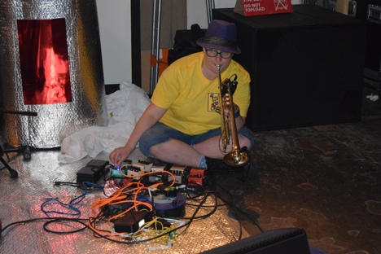  ID: Robyn ( a white woman , yellow t shirt and purple hat ) sat on the floor playing the trumpet . | Robyn will play some trumpet as you are coming into café oto
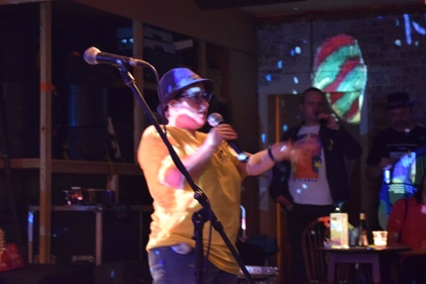  ID: Robyn – a white woman with yellow t shirt and purple hat speaking in a microphone | When it is time for the gig to begin , Robyn will turn her trumpet down and start speaking in the microphone
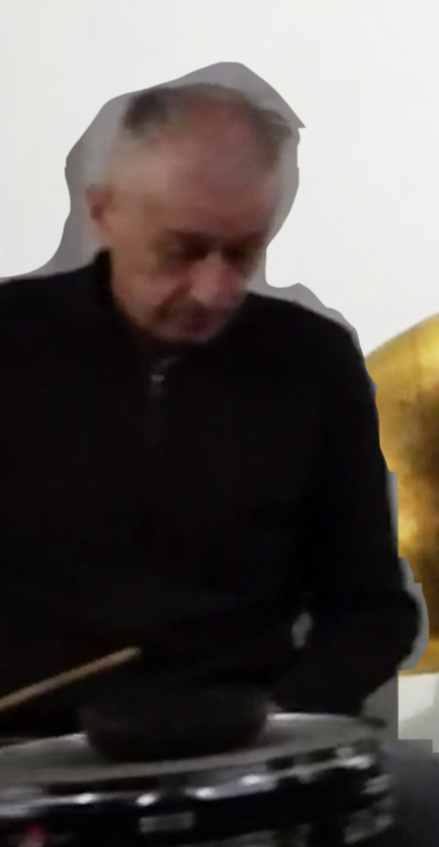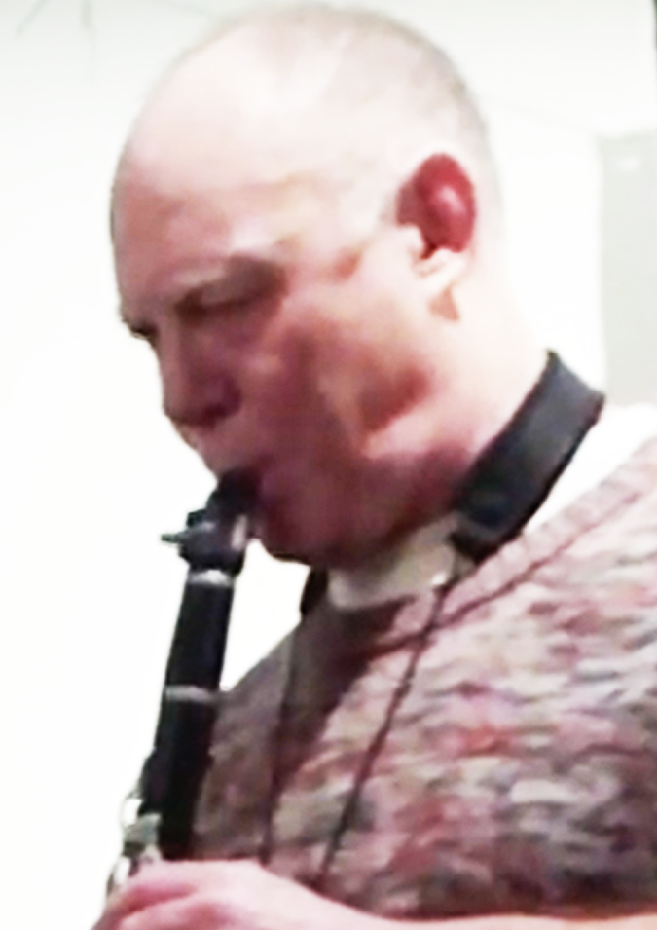  ID : a white man playing the drums and a white man playing the clarinet | If we are able to open the doors at 7:45 , there will be a 30 minute performance by Alan Wilkinson and Robyn Rocket , Steve nobel may play the drums  They are represented by the yellow triangle on the timetable Merch table and stage.
Image description : Symbol of a pint glass | After Akan , steve and Robyn have play’d there will be a break. There are a Few things you can do in the break, you can do any or all of these things;  1 chatting to people  2 Get a drink from the bar  3 go outside  watch the the live stream feed ( see www.cafeoto.co.uk)  5 do nothing  6 fill in a card star with feedback  7
ID a white woman with a purple hat | Robyn will speak in the microphone to welcome everyone
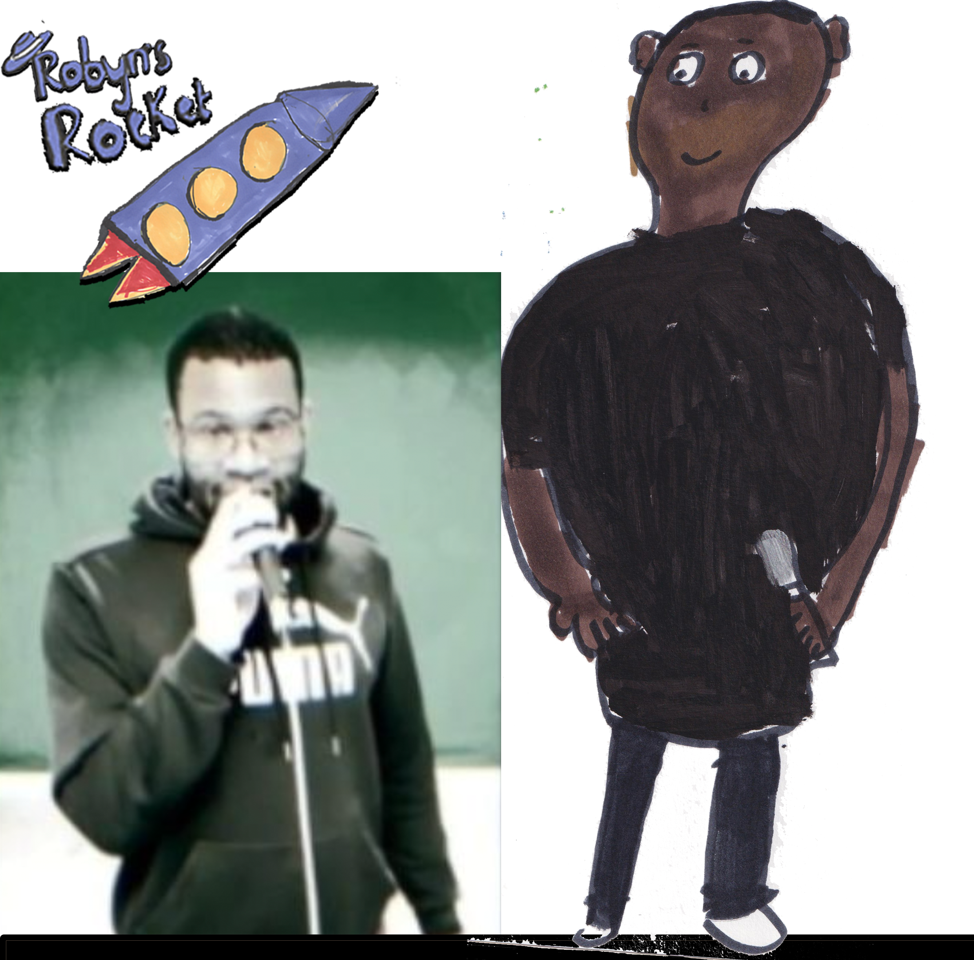  ID: 2 black men with short hair holding microphones. | The next artists to perform are called 2 Decks and Mr AKA Amazing they are hip hop artists they are represented by the blue square on the timetable and merch table
Image description pint glass | After 2 decks and Mr AKA Amazing have play’d there will be a break, there are a Few things you can do in the break you can do any or all of these things  1 chatting to people  2 Get a drink from the bar  3 go outside  4 watch the the live stream feed ( see www.cafeoto.co.uk)  5 do nothing  6 fill in a card star with feedback
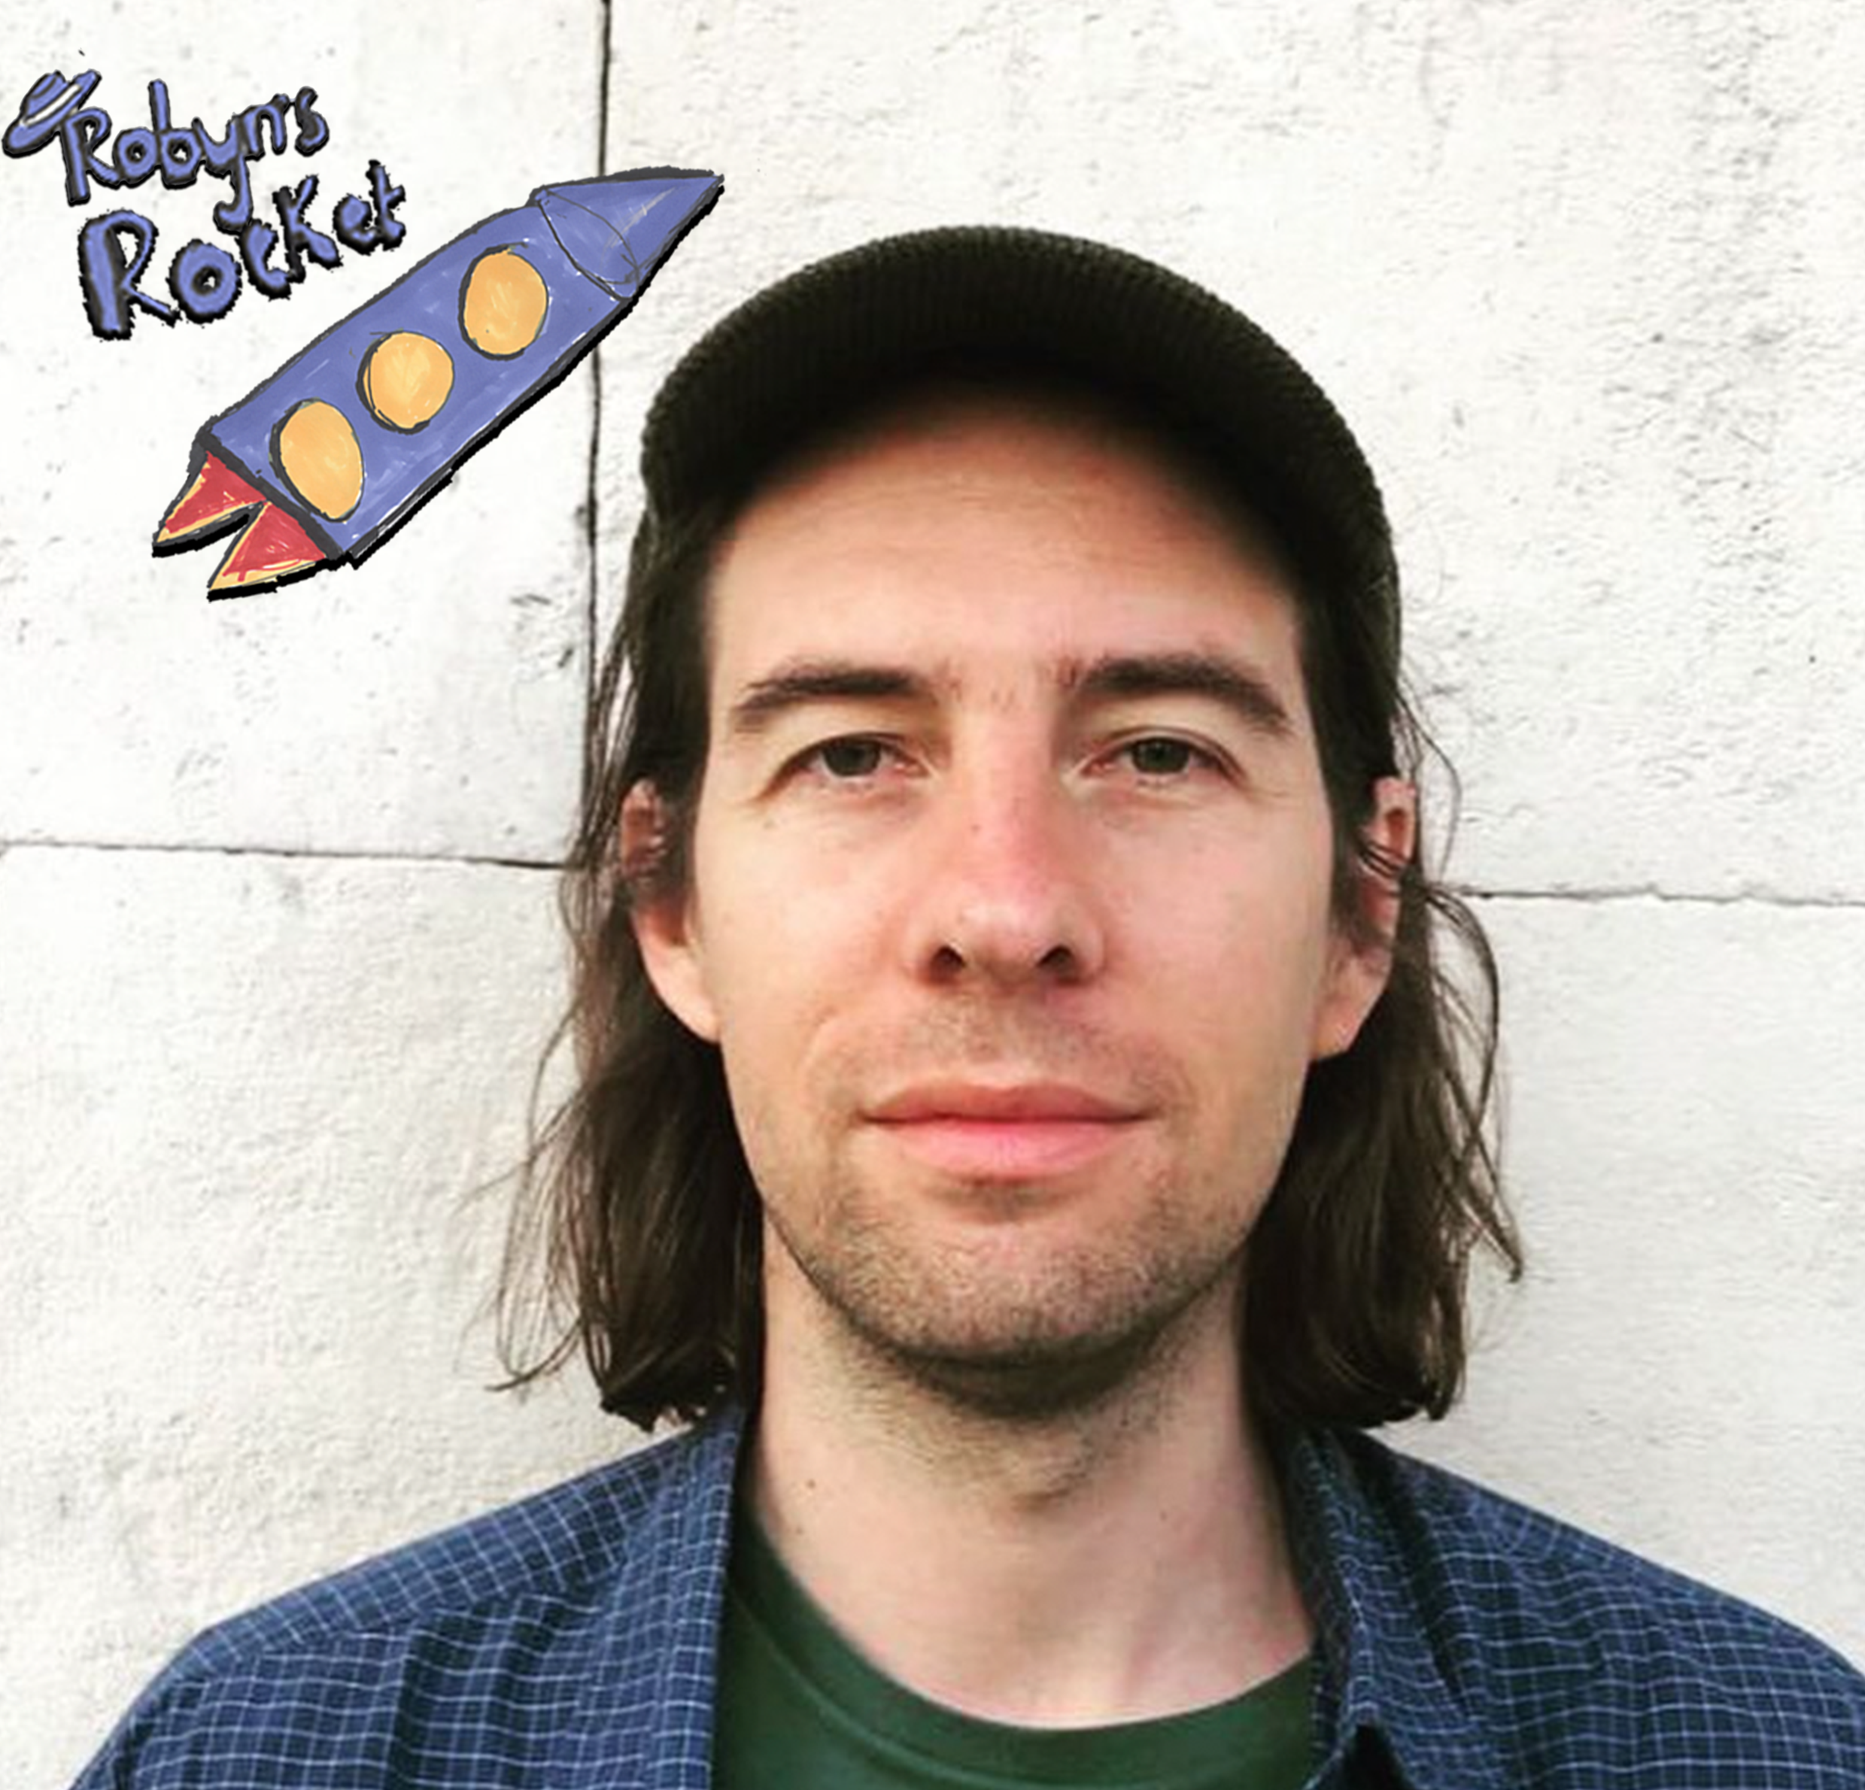  ID : a white man with shoulder length hair and baseball cap | The next musician to play is called James Howard, she will be joined by 6 other musicians, they will be singing , playing the drums, playing guitar and synths and bass. They are represented by the green circle on the merch table , stage and timetable.
Image description pint glass | After James Howard and his band have play’d there will be a break, there are a Few things you can do in the break you can do any or all of these things  1 chatting to people  2 Get a drink from the bar  3 go outside  4 watch the the live stream feed ( see www.cafeoto.co.uk)  5 do nothing  6 fill in a card star with feedback
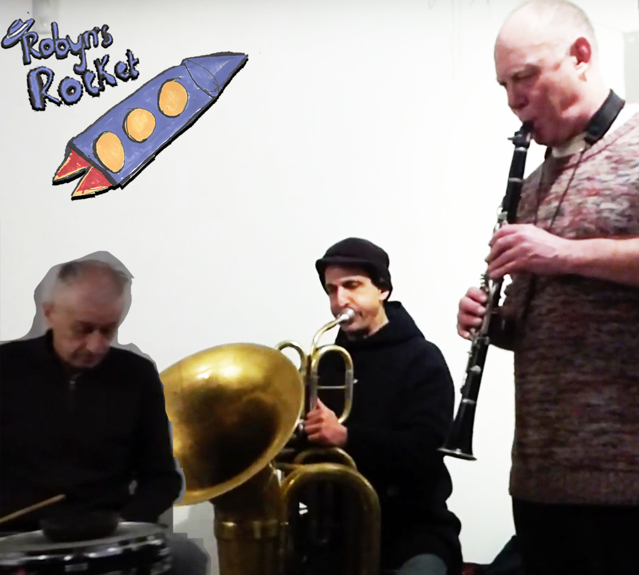  ID : a white man playing the drums and a white man playing the clarinet, a man playing the tuba. All the men have short hair | Alan Wilkinson , Oren Marshall and Steve Nobel will play .  They are represented by the yellow triangle on the timetable Merch table and stage.
 | On the timetable it says there might be a special guest or you can chat to people, café OTO will be open until midnight.

