Robyn’s Rocket social story
Robyn’s Rocket will happen on Thursday 17th November 2022 8-11:30pm, It is a relaxed performance so you do not have to stay in the space the whole time, and can do what you need to feel comfortable e.g stim , tic etc
ID = Image description
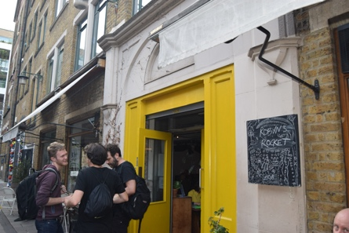  ID a building with a yellow door (the door has been painted since this photo and is green) a group of people stand outside with a chalkboard that says Robyn’s Rocket | You might have to wait outside until café OTO is ready
ID: a line of people entering through the yellow doors and talking to a person sat at a table . | When the doors are opened you can come inside café OTO.  You will be asked  if you have bought a ticket or would like to buy one
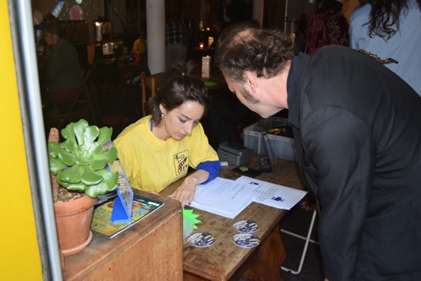  ID : a man in a dark jacket speaks to someone in a Robyn’s Rocket crew T shirt sat at a desk. | If you have bought a ticket the person sitting by the door will ask for your name so they can find your name on the list of people who have bought tickets. NOTE We do not give out physical tickets
ID : a man in a dark jacket speaks to someone in a Robyn’s Rocket crew T shirt sat at a desk. | If you have not bought a ticket , you will be asked if you would like to pay by Cash or card. You can pay the person at the table . NOTE We do not give out physical tickets
ID: outline of a stamp | You will be offered a stamp on your hand, it is ok to say no.
ID: a badge made from silver card in the shape of a rocket with 3 purple windows | You will be given a rocket badge  The rocket badge is used to tell other people how much communication you want with other people
ID: a badge made from silver card in the shape of a rocket with 3 purple windows Rocket pointing up | Place your rocket with the tip pointing toward the sky if your happy to talk to anyone
Photo description a badge made from silver card in the shape of a rocket with 3 purple windows Rocket pointing sideways | Place your rocket sideways if you inly want to talk to people you know already ,
Photo description a badge made from silver card in the shape of a rocket with 3 purple windows Rocket pointing down | place your rocket with the tip pointing toward the floor if you do not want to talk to anyone  You can change your rocket position as much as you want.
ID: Symbols for ear defenders, sunglasses and ear plugs. | If you want to you can borrow a pair on sunglasses or ear defenders , or have a pair of ear plugs , you can get these at anytime.
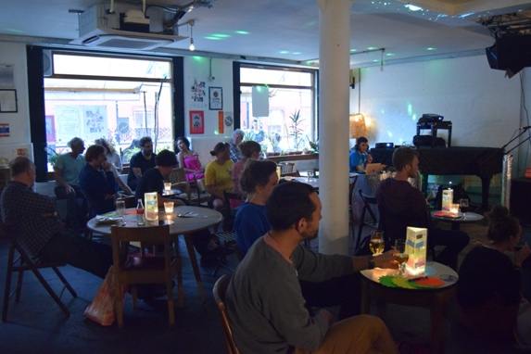  ID: Café OTO inside a room with large windows and small tables with lights | Choose somewhere to sit or stand  You can sit or stand anywhere that is not blocking the fire exit , entrance, toilets doors.
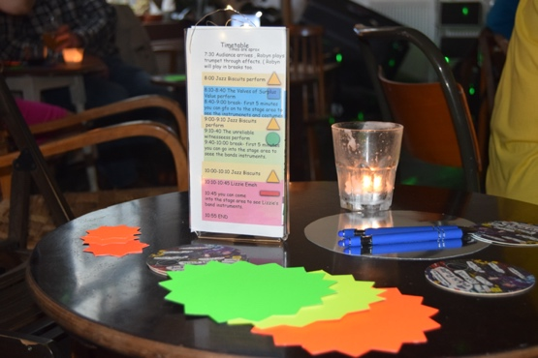  ID: a table with a plastic timetable holder , candle , card stars ,and pen and a symbol of a whiteboard | On the table you will find  Pens  Card stars  Timetable with light
ID: a symbol of a whiteboard with a yellow outline , and yellow rubber. | There will also be some whiteboards on some of the tables.
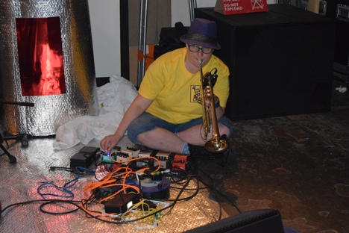  ID: Robyn ( a white woman , yellow t shirt and purple hat ) sat on the floor playing the trumpet . | Robyn will play some trumpet as you are coming into café oto
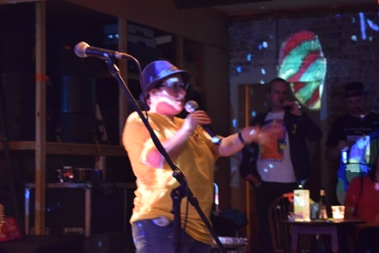  ID: Robyn – a white woman with yellow t shirt and purple hat speaking in a microphone | When it is time for the gig to begin , Robyn will turn her trumpet down and start speaking in the microphone
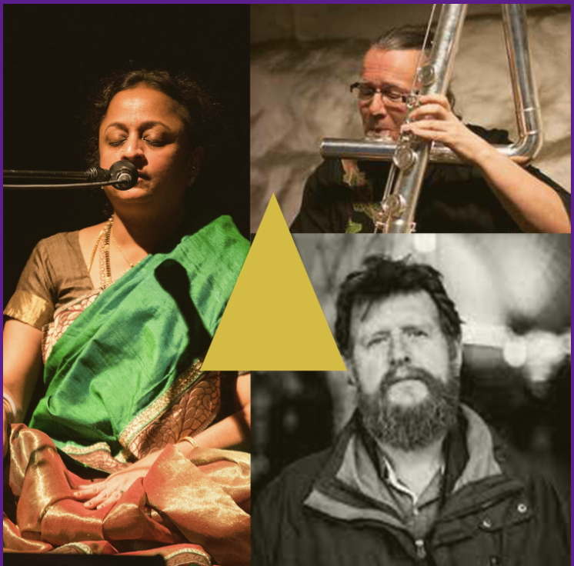  ID : 3 people , a person in a in a sari singing into a microphone , a person with a big flute , a person with a big beard. | The first band to play are called  Supriya Nagarajan  Patrick Shaw Iversen  Duncan chapman  They are represented by the yellow triangle on the timetable Merch table and stage.
Image description : Symbol of a pint glass | After Supriya, Patrick and Duncan have play’d there will be a break. There are a Few things you can do in the break, you can do any or all of these things;  1 chatting to people  2 Get a drink from the bar  3 go outside  4 watch the youtube feed ( see www.robynsrocket.com)  5 do nothing  6 fill in a card star with feedback  7 mark on the whiteboard where you are from
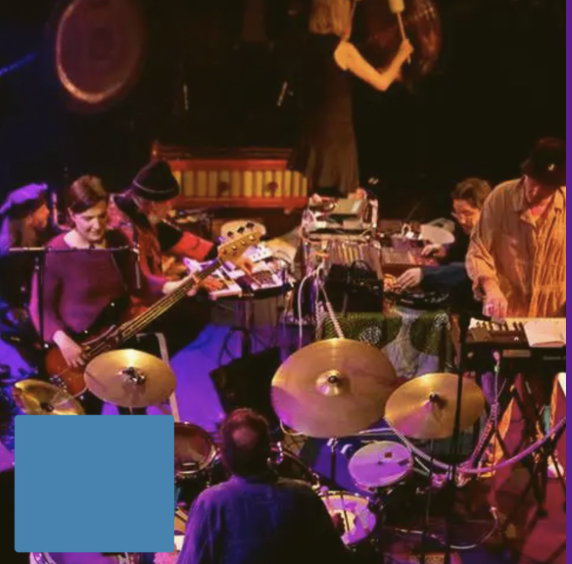  ID a group of people on a stage playing drums , synths , tape machines , bass guitar and keyboard , with a blue square in the corner. | The next band to play are called Floating World Pictures. They are represented on the timetable. Merch table and stage by the Blue square
Image description pint glass | After Floating World pictures have play’d there will be a break, there are a Few things you can do in the break you can do any or all of these things  1 chatting to people  2 Get a drink from the bar  3 go outside  4 watch the youtube feed ( see www.robynsrocket.com)  5 do nothing  6 fill in a card star with feedback  7 mark on the whiteboard where you are from
ID : a black woman on a red background. A green circle is on the picture | The next musician to play is called Donna Thompson, she will be joined by 2 other musicians, they will be singing , playing the drums, playing piano and synths and bass. They are represented by the green circle on the merch table , stage and timetable.
Photo description Robyn in purple hat , yellow t shirt speaking into a microphone. | After Donna and her band have played Robyn will thank everyone for coming and you can leave café OTO and go home.
 | On the timetable it says there might be a special guest or you can chat to people, café OTO will be open until midnight.

